**ENVINT FINANCIAL RISK MANAGEMENT**

**Executive Summary**

ENVINT Financial Risk Management is a robust, secure, and scalable platform designed to assess financial risk across multiple companies and industry sectors. The system provides authenticated users with the ability to upload and analyze financial data, perform risk assessments, and generate insights based on key financial metrics. Built on a modern Node.js architecture with MongoDB for data persistence and Redis for job queuing, the application delivers high-performance data processing capabilities while maintaining security best practices.

This report provides a comprehensive technical overview of the system's architecture, implementation details, security considerations, performance optimizations, and potential areas for future development.

**1. System Architecture**

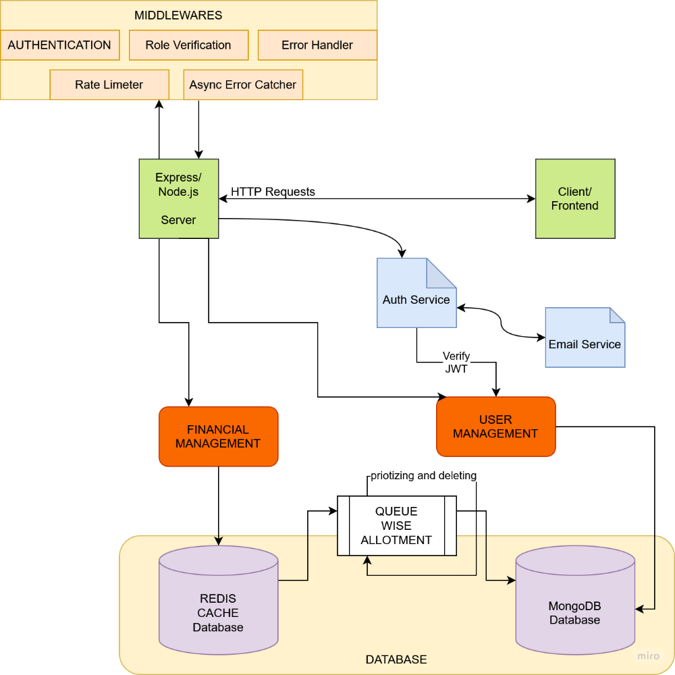

**1.1 Technology Stack**

The ENVINT Financial Risk Management platform utilizes a comprehensive technology stack:

* **Backend Framework**: Express.js on Node.js
* **Database**: MongoDB (primary data store)
* **Caching & Queue**: Redis with BullMQ
* **Authentication**: JWT-based authentication with secure cookie storage
* **Email Services**: Nodemailer for transactional emails
* **Validation**: Custom validation with validator.js
* **Security**: bcrypt for password hashing, rate limiting, and comprehensive error handling

**1.2 System Components**

The application follows a modular architecture with clear separation of concerns:

* **API Layer**: RESTful endpoints for authentication, user management, and financial data processing
* **Service Layer**: Business logic encapsulated in dedicated service classes
* **Data Access Layer**: MongoDB models with Mongoose ODM
* **Background Processing**: Asynchronous job processing using Redis-backed BullMQ queues
* **Middleware Layer**: Request authentication, error handling, and rate limiting

**1.3 Directory Structure**

The codebase follows a well-organized directory structure that promotes maintainability and separation of concerns:

backend/

├── config/ # Configuration files

│ └── databases/ # Database connection modules

├── controllers/ # Request handlers

├── middleware/ # Express middleware

├── models/ # MongoDB schemas

├── routes/ # API route definitions

├── services/ # Business logic services

├── utils/ # Utility functions

├── workers/ # Background job processors

└── app.js # Application entry point

**2. Core Functionality**

**2.1 Authentication System**

The authentication system implements a secure, token-based approach with several key features:

* User registration with email validation
* Secure login with JWT token generation
* Token storage in HTTP-only cookies for XSS protection
* Password reset via secure email links with expiring tokens
* Session management with logout functionality

The authentication flow is managed by dedicated controller functions in authController.js:

1. **Registration**: Validates user input, checks for existing users, securely hashes passwords, and generates JWT tokens
2. **Login**: Authenticates credentials, issues JWT tokens, and sets secure cookies
3. **Password Reset**: Implements a secure two-step process with unique tokens and email verification

**2.2 Financial Data Processing**

The financial data processing component enables:

* Bulk upload of financial records (up to 500 per request)
* Asynchronous processing via Redis-backed queues
* Risk assessment calculations and data retrieval
* Filtering by company ID, reporting period, and industry sector

The system employs a worker-based architecture to handle data processing asynchronously:

1. uploadFinancialData controller accepts financial data and queues it for processing
2. financialQueue.js manages the job queue with retry mechanisms
3. financialWorker.js processes queued items and saves them to MongoDB
4. getRiskAssessment retrieves and filters processed data

**2.3 User Management**

User management features include:

* Profile updates (username and email)
* Secure password changes with current password verification
* Account deletion
* Profile information retrieval

Each operation enforces proper authentication via middleware and includes appropriate validation.

**3. Data Models**

**3.1 User Model**

The User model (userModel.js) stores essential user information:

* Username
* Email (unique, validated)
* Password (hashed using bcrypt)
* Timestamps for creation and updates

The schema includes validation rules and custom methods for:

* Password hashing via pre-save hooks
* Password comparison
* JWT token generation

**3.2 Financial Data Model**

The Financial model (financialModel.js) captures comprehensive financial metrics:

* Company identification (ID and name)
* Reporting period
* Industry sector
* Financial indicators (assets, liabilities, revenue, profit)
* Calculated ratios (debt-to-equity, interest coverage)
* Risk assessment scores (Z-score, risk score)

The schema includes a compound index for company_id and reporting_period to ensure unique entries per reporting period.

**3.3 Password Reset Model**

The PasswordReset model (passwordResetModel.js) supports secure password recovery:

* User ID reference
* Reset token (hashed for security)
* Expiration timestamp (15 minutes from creation)

The system enforces single active reset requests per user by removing previous tokens.

**4. API Routes and Controllers**

**4.1 Authentication Routes**

POST /api/v1/auth/register # Create new user account

POST /api/v1/auth/login # Authenticate user

POST /api/v1/auth/logout # Terminate user session

POST /api/v1/auth/forgot-password # Request password reset

PUT /api/v1/auth/reset-password/:token # Complete password reset

**4.2 User Routes**

GET /api/v1/user/me # Retrieve user profile

PUT /api/v1/user/me # Update user profile

PUT /api/v1/user/change-password # Change user password

DELETE /api/v1/user/me # Delete user account

**4.3 Financial Routes**

POST /api/v1/financial/uploadFinancialData # Submit financial data

GET /api/v1/financial/getRiskAssessment # Retrieve risk analysis

All routes are protected by appropriate middleware for authentication and rate limiting.

**5. Security Implementation**

**5.1 Authentication Security**

The application implements multiple security layers:

* Password hashing with bcrypt (10 rounds)
* JWT tokens with configurable expiration
* HTTP-only cookies with strict same-site policy
* Token verification middleware for protected routes
* Rate limiting on authentication endpoints (20 attempts per 15 minutes)

**5.2 Data Protection**

Data protection measures include:

* Input validation for all user-submitted data
* MongoDB schema validation
* Error handling that avoids leaking sensitive information
* Secure password reset flows with unique, time-limited tokens
* Strict rate limiting on sensitive operations (e.g., 5 password reset attempts per 15 minutes)

**5.3 Error Handling**

The application employs a centralized error handling approach:

* Custom ErrorHandler class for standardized error responses
* Async error wrapper to catch Promise rejections
* Specific error handling for various error types (JWT errors, MongoDB errors)
* Environment-aware error details (stack traces only in development)

**6. Performance Optimizations**

**6.1 Asynchronous Processing**

The application optimizes performance through:

* Asynchronous job processing for financial data
* BullMQ for reliable job queuing with retries
* Worker processes that operate independently of the web server

**6.2 Database Optimizations**

Database performance is enhanced through:

* Strategic indexing on frequently queried fields
* Compound unique indexes to enforce data integrity
* Query limiting to prevent excessive result sets
* Selective field projection to reduce data transfer

**6.3 Caching Strategy**

Redis is employed for:

* Job queuing with persistence
* Potential session storage
* Future expansion for response caching

**7. Scalability Considerations**

**7.1 Horizontal Scaling**

The system architecture supports horizontal scaling through:

* Stateless authentication (JWT tokens)
* Separation of web servers and background workers
* Redis for centralized queue management
* MongoDB's native scaling capabilities

**7.2 Queue Management**

The BullMQ implementation includes several features to support high-volume processing:

* Exponential backoff for failed jobs
* Configurable retry limits
* Job completion and failure tracking
* Independent worker processes

**8. Email Service Integration**

**8.1 Transactional Email System**

The application includes a comprehensive email service:

* Modular EmailService class with SMTP configuration
* Template-ready message formatting
* Error handling with appropriate logging
* Used for password reset communication

**8.2 Email Security**

Email security considerations include:

* Configurable SMTP settings via environment variables
* Support for secure connections (TLS/SSL)
* Error handling to prevent information leakage
* Rate limiting on email-generating endpoints

**9. Testing Strategy**

**9.1 Unit Testing**

The directory structure includes a dedicated test folder with test files corresponding to application components:

* Route tests (financialRoutes.test.js)
* Future expansion for controller and service tests

**9.2 Integration Testing**

The architecture supports integration testing through:

* Modular components with clear interfaces
* Error handling that facilitates testing
* Middleware design that allows for isolated testing

**10. Deployment Architecture**

**10.1 Environment Configuration**

The application uses dotenv for environment-specific configuration:

* Database connection strings
* JWT secret keys and expiration times
* SMTP settings
* Redis connection parameters
* Port configuration
* Environment mode (development/production)

**10.2 Server Setup**

The server initialization follows a controlled sequence:

1. Load environment variables
2. Establish MongoDB connection
3. Configure Express application with middleware
4. Start HTTP server
5. Initialize background workers

**11. Future Enhancements**

**11.1 Technical Improvements**

Potential technical enhancements include:

* **GraphQL API**: Implementation of a GraphQL layer for more efficient data retrieval
* **Caching Layer**: Enhanced Redis caching for frequently accessed data
* **Microservices Architecture**: Breaking down the monolith into specialized services
* **WebSocket Support**: Real-time updates for financial data and risk scores
* **Containerization**: Docker and Kubernetes deployment configurations

**11.2 Feature Enhancements**

Future feature additions could include:

* **Advanced Analytics**: Machine learning models for predictive risk assessment
* **Reporting Module**: Customizable report generation with PDF export
* **Dashboard**: Interactive visualization of financial metrics
* **Multi-factor Authentication**: Enhanced security options
* **Role-based Access Control**: Granular permissions system
* **Audit Logging**: Comprehensive activity tracking

**12. Conclusion**

The ENVINT Financial Risk Management platform demonstrates a well-architected, secure, and scalable application for financial data processing and risk assessment. By leveraging modern technologies and following best practices in software development, the system provides a solid foundation for financial analysis with room for expansion and enhancement.

The modular design, comprehensive error handling, and security-focused implementation ensure that the platform can reliably manage sensitive financial data while providing valuable insights to authenticated users. As financial risk management requirements evolve, the system's architecture will allow for graceful adaptation and feature expansion.